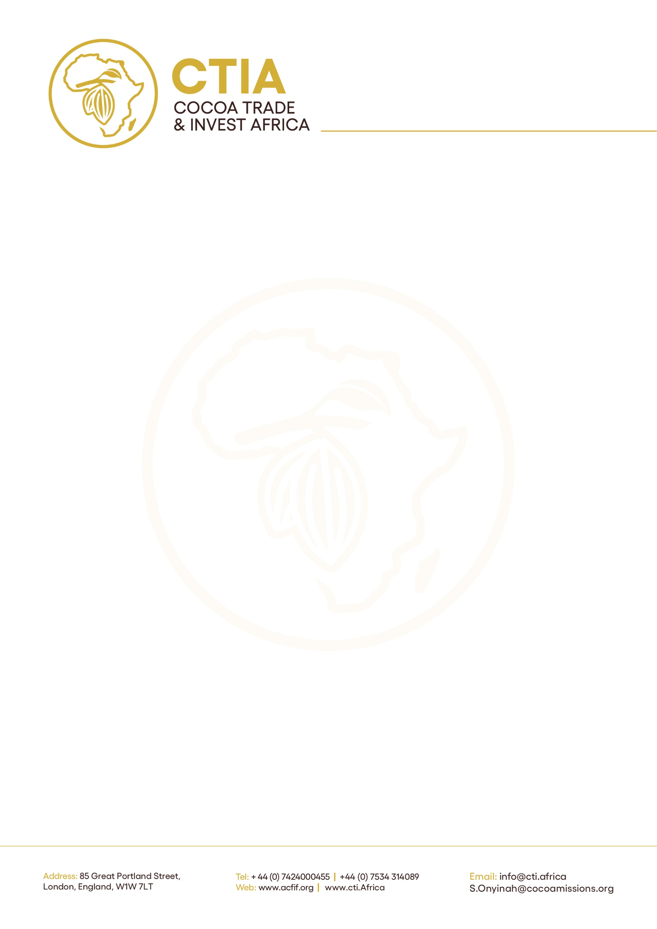

Ref: ACTIF/F/CTIA/04/26/15
Date: May 1, 2026.

FOR IMMEDIATE RELEASE
H.E. John Agyekum Kufuor to Deliver Special Address on Africa Cocoa Vision 2050 at Inaugural ACFIF 2026
The inaugural Africa Cocoa Finance & Investment Forum (ACFIF 2026) will feature a Special Address by H.E. John Agyekum Kufuor, former President of the Republic of Ghana, under the theme: “Africa Cocoa Vision 2050 – Historical Reflections and Future Pathways.”
The high-level forum, taking place at the London Stock Exchange on May 6, 2026, will convene global investors, policymakers, development institutions, and private sector leaders to explore transformative opportunities across Africa’s cocoa value chain.
President Kufuor’s address is expected to set the tone for strategic dialogue at ACFIF 2026, offering a rare perspective that bridges Africa’s cocoa legacy with the imperatives of future growth. Drawing on his longstanding leadership and advocacy for agricultural development, as well as his experience as a cocoa farmer, he will outline a forward-looking vision for repositioning cocoa as a driver of industrialisation, regional integration, and sustainable economic development across the continent.
During his tenure from 2001 to 2008, President Kufuor led one of the most transformative periods in Ghana’s cocoa sector. Production increased from approximately 300,000 tonnes in 2001 to about 750,000 tonnes by the 2003/04 season, driven by the nationwide institutionalisation of mass cocoa spraying and the introduction of hi-tech fertiliser support programmes.
He further prioritised value addition by creating incentives that attracted major global and local processors, including Barry Callebaut, Olam, Cargill, Niche Cocoa, and CHOCOMAC, laying the foundation for Ghana’s modern cocoa processing industry. These reforms ultimately contributed to Ghana achieving its historic 1 million tonne cocoa harvest in the 2010/11 season.
The Special Address will be followed by a high-level panel discussion on “Africa Cocoa Vision 2050: Opportunities for Regional Growth & Transformation.” The session will bring together key stakeholders to examine practical pathways for unlocking investment, enhancing value addition, and strengthening Africa’s competitiveness in global cocoa markets.
Key partners, Sunbeth Global Concepts and Johnvents Industries Limited (Nigeria) are supporting the forum’s technical discussions through the participation of senior representatives as panelists, contributing expertise on financing frameworks, market development, and value chain transformation.

Distinguished panelists include Olasunkanmi Owoyemi, Managing Director of Sunbeth Global Concepts, and H.E. Alex Assanvo, Executive Secretary of the Cote d’Ivoire-Ghana Cocoa Initiative.
A second session, “Reimagining Cocoa Value Addition: Financing Chocolate Manufacturing, Nutraceuticals & Pharmaceutical Innovation,” will focus on opportunities beyond primary processing, including industrial applications of cocoa.
Contributors to this session include Patricia Poku-Diaby of Plot Enterprises, and Vishnu Kakra of Johnvents, who will address strategies for scaling value-added production and expanding into emerging segments.
In addition, Executive Director of the International Cocoa Organization (ICCO), Michel Arrion, will deliver a keynote address introducing the African Cocoa Exchange (AfCX), a proposed platform aimed at enhancing market transparency, improving price discovery, and strengthening Africa’s position within global cocoa trade systems.
ACFIF 2026 marks the first edition of what is set to become a premier global platform dedicated to mobilising finance and partnerships for Africa’s cocoa economy. The forum will focus on bridging the gap between investment capital and bankable opportunities, while fostering dialogue on policy, trade, and innovation across the sector.

End.

About ACFIF
The Africa Cocoa Finance & Investment Forum (ACFIF) is a high-level convening platform designed to catalyse investment, partnerships, and policy alignment within Africa’s cocoa sector. By connecting governments, investors, industry leaders, and development partners, ACFIF aims to drive a more sustainable, inclusive, and value-added cocoa economy across the continent.
The Forum is convened by Cocoa Trade & Invest Africa and DMA Invest, in collaboration with the Institute of Directors (IoD) Africa Group.

Media Contact:
ACFIF Secretariat
Email: s.onyinah@cocoamissions.org
Website: https://www.acfif.org/

